Computer Network Lab
Project Report
Chat Application

Submitted by:
Muhammad Kamran 2024-SE-24
M. Ahsan Sadiq 2024-SE-40
Aoun Muhammad 2024-SE-45

Submitted to:
Mr. Nouman Munir

Department of Computer Science
University of Engineering and Technology Lahore, New Campus.
Chat Application

Contents
1. Abstract 3
2. Introduction 3
3. Problem Statement 3
4. Objectives 3
5. Scope and Features 4
5.1 Scope 4
5.2 Key Features 4
6. Tools and Technologies 4
6.1 Software Tools and Libraries 4
6.2 Hardware Requirements 4
7. Proposed Methodology 5
7.1 Server-Side Logic 6
7.2 Client-Side Logic 6
8. Workflow Diagrams 6
8.1 Login Flow 6
8.2 Video Call Flow 6
9. Conclusion 8

1. Abstract
SpeakMe is a robust, Python-based real-time communication system designed to facilitate text, audio, and video interaction between users over a local network or internet connection. Utilizing a Client-Server architecture, the application creates a centralized hub (Server) that manages connections, routes messages, and orchestrates group interactions. The Client interface, built with Tkinter, provides a user-friendly GUI supporting private messaging, group chats, file transfer, voice notes, and live audio/video calls using OpenCV and PyAudio. This project demonstrates the integration of multi-threaded networking with complex media handling in a desktop environment.

2. Introduction
In modern computing, real-time communication is a fundamental requirement. While web-based solutions exist, desktop applications often provide more direct access to hardware resources. SpeakMe bridges the gap between simple socket-based text chat and full-featured commercial messengers. It implements a custom application-layer protocol using JSON over TCP sockets to handle various data types—from simple text strings to binary streams for video calls—providing a seamless user experience similar to applications like WhatsApp or Telegram, but contained within a lightweight Python environment.

3. Problem Statement
Developing a chat application involves overcoming several synchronization and data handling challenges:
- Blocking I/O: Standard socket operations block the execution flow, freezing GUIs.
- Data Fragmentation: Sending large files (images/audio) over a network often results in fragmented packets that must be reconstructed.
- Media Streaming: Real-time audio and video require low-latency transmission and immediate playback/rendering, which differs significantly from standard file transfer.
- State Management: Tracking online users, group memberships, and connection states across multiple concurrent clients requires a robust central logic.
SpeakMe addresses these by using a multi-threaded architecture to decouple network I/O from the UI and employing efficient encoding (Base64/JPEG) for media transmission.

4. Objectives
The primary objectives of this project are:
- To establish a stable TCP connection between multiple clients and a central server.
- To create a responsive Graphical User Interface (GUI) that does not freeze during network operations.
- To implement robust private and group messaging logic.
- To enable binary file transfer (documents, images).
- To implement a voice recording and playback system (Voice Notes).
- To achieve real-time video and audio calling capabilities between clients.

5. Scope and Features

5.1 Scope
The application operates on a Local Area Network (LAN) or a WAN (provided the server IP is accessible). It is designed for desktop environments (Windows/Linux/macOS) supporting Python.

5.2 Key Features
- User Authentication: Simple username-based login.
- Dashboard: Sidebar displaying online users and active groups with 'Green Dot' status indicators.
- Messaging Modes: Public Chat (Broadcast), Private Chat (1-on-1), and Group Chat.
- Media Sharing: File Transfer (docs/images) and Voice Notes (WAV encoding).
- Real-Time Calling: Video Calls via OpenCV and Audio Calls via PyAudio.
- Notifications: Visual 'Toaster' popups and sound alerts for incoming messages.

6. Tools and Technologies

6.1 Software Tools and Libraries
- Language: Python 3.x
- GUI Framework: tkinter, tkinter.ttk
- Networking: socket (TCP/IP), json
- Concurrency: threading
- Multimedia: cv2 (OpenCV), pyaudio, wave, PIL (Pillow), base64

6.2 Hardware Requirements
- Processor: Dual-core processor or better (for handling video encoding).
- Network: LAN or Internet connection.
- Peripherals: Microphone, Webcam, Speakers/Headphones.

7. Proposed Methodology
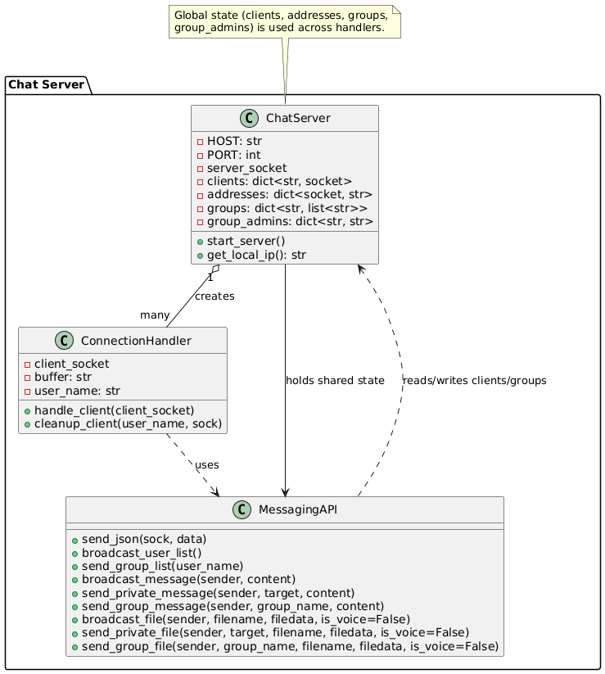
The system follows a star topology where all clients connect to the central server. Communication relies on a custom JSON protocol.

Figure 1 Class Diagram illustrating system architecture.

7.1 Server-Side Logic
The server acts as a router and state manager. It initializes by binding to a port and listening for connections. A dedicated thread is spawned for each client using the `handle_client` function. The server parses incoming JSON packets (up to 2MB) and routes them based on the 'type' field (e.g., LOGIN, PRIVATE_MSG). It also manages group states and relays streaming data for calls.

7.2 Client-Side Logic
The client handles the UI, media capture, and packet construction. The `ChatClient` class initializes the main window and connects to the server using a TCP socket. A background thread `receive_messages` listens for data to prevent UI freezing. Media handling includes recording audio chunks via PyAudio and capturing video frames via OpenCV, encoding them to Base64 for transmission.

8. Workflow Diagrams

8.1 Login Flow
Client -> Connects Socket -> Sends JSON LOGIN -> Server Adds to dict -> Broadcasts USER_LIST.

8.2 Message Transmission Flow
- User types a message in the client interface.
- Client packs the message into a JSON object (type, sender, target, content
- JSON packet is sent to the server through the active TCP socket.
- Server receives the packet and checks whether it is PUBLIC, PRIVATE, or GROUP.
- Based on the message type, the server forwards it to the intended user(s).
- Receiving clients process the JSON packet in their listener thread.
- Clients update the chat window instantly without freezing the GUI.
- Message appears in real time for all targeted recipients.

8.3 Video Call Flow
- User A sends VIDEO_CALL_REQUEST.
- Server forwards to User B.
- User B accepts -> Sends CALL_ACCEPTED.
- Both start streaming threads (Capture -> Base64 -> Server -> Target -> Decode -> Display).
The following sequence diagram details the interaction flow for Login, Messaging, and Calling :
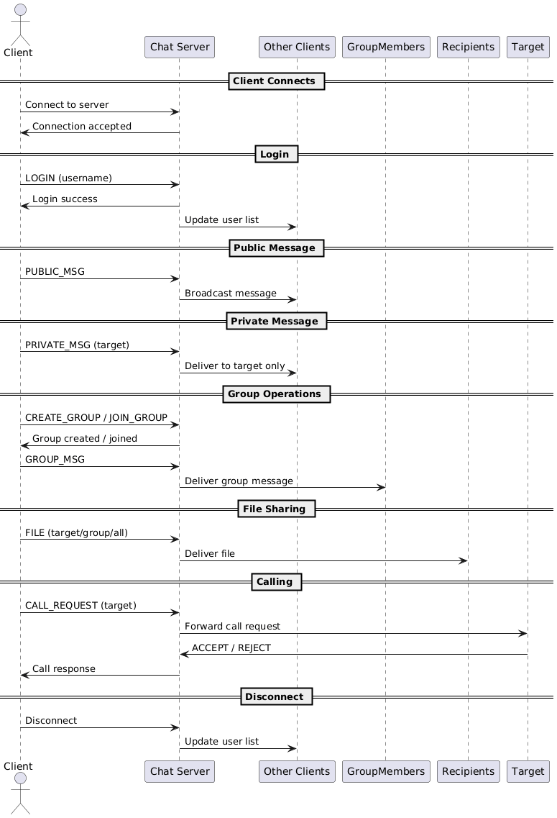 Figure 2: Sequence Diagram detailing packet flow.

9. Conclusion
SpeakMe successfully demonstrates a full-stack desktop application approach using Python. By managing threads effectively and utilizing efficient encoding for media, it allows for seamless text and multimedia communication, mimicking the core functionality of major enterprise messaging platforms within a custom, open-source framework.

